A Fractal Vector Quantizer for Image Coding
Chang-Su Kim, Rin-Chul Kim, and Sang-Uk Lee
IEEE Transactions on Image Processing, Vol. 7, No. 11, pp. 1598-1602, Nov. 1998
Abstract
In this paper, we investigate the relation between VQ and fractal image coding techniques, and propose a novel algorithm for still image coding, based on fractal vector quantization (FVQ).
- Introduction
Fractal image coding techniques have some similarity with vector quantization (VQ). From the view point of VQ, the fractal coders generate the codebook by transforming the source image itself, and find an optimal codeword for each range block.
- Fractal Vector Quantization (FVQ)
˙conventional fractal image coding
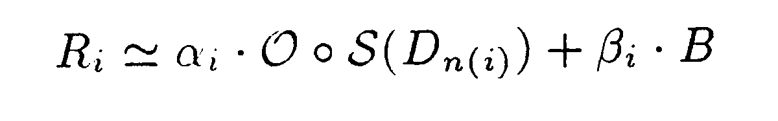
˙FVQ
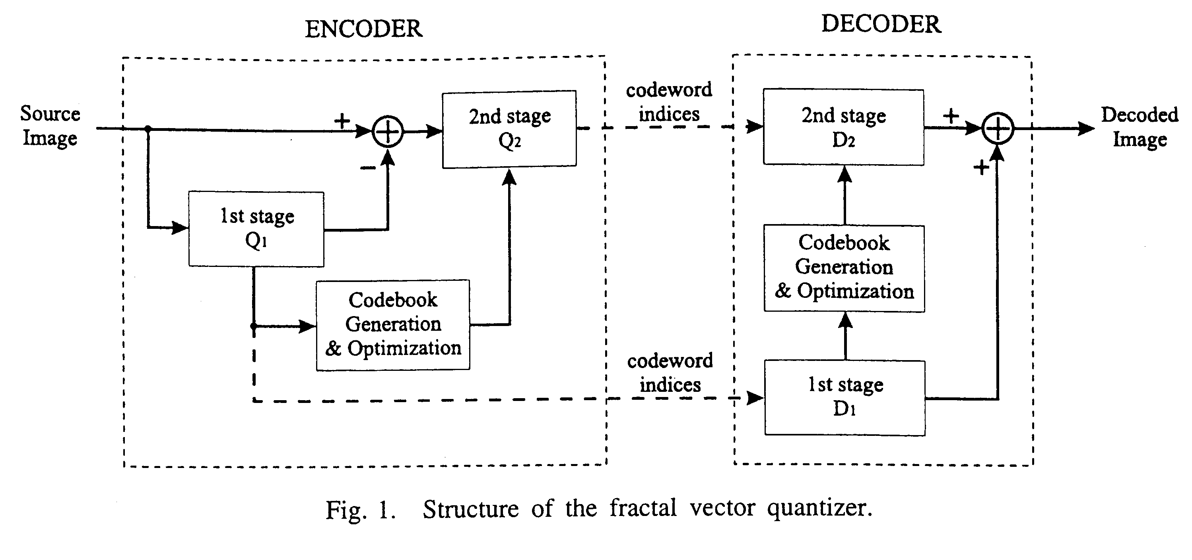
- Implementation of Coder
- Encoding Algorithm
- Partitioning Image and Planar Approximation:
The source image is partition into the range blocks of maximum size of 32×32 and minimum size 4×4, based on the quadtree structure, and each range block is coarsely approximated by a plane.
The optimal planar approximation 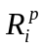 is obtained from
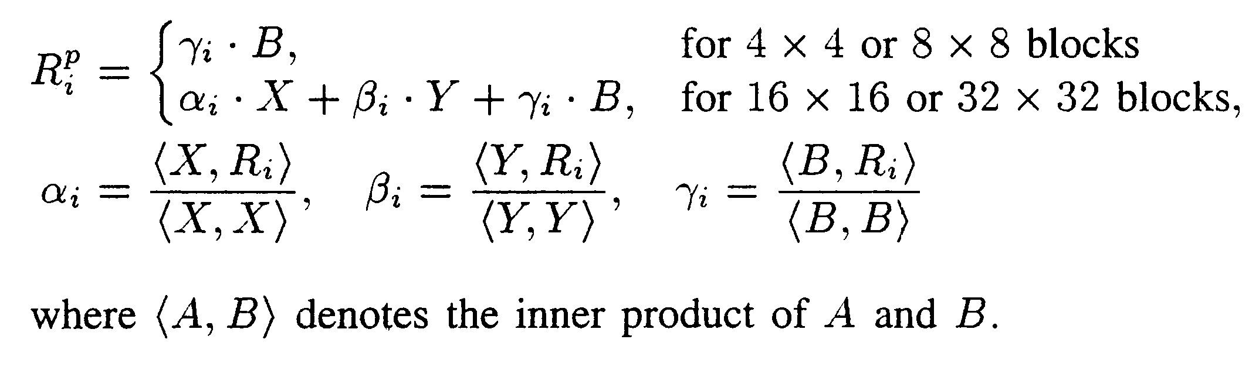

- Codebook Generation and Optimization:
The FVQ coder transforms the planarly approximated image into the Γ₁ and Γ₂ images using the spatial contraction operator and the smoothing operator.

- Fine Quantization of Range Blocks:
Each r×r range block R_{i} is finely quantized using the codebook C_{r} = {C_{n}; 1 ≤ n ≤ s}.

- Decoding Algorithm
First, the planarly approximated image is reconstructed with the quadtree information. Second, the planarly approximated image is transformed into the Γ₁ and Γ₂ images. Last each range block is reconstructed using the codeword in these codebooks.

- Simulation Results
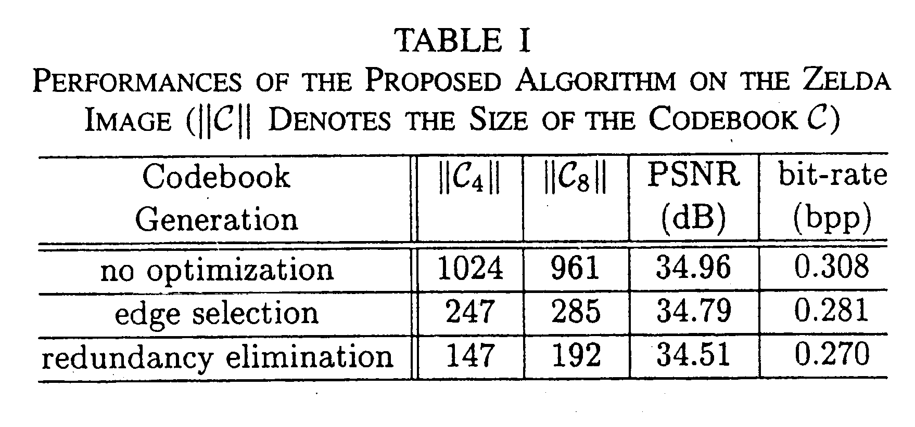
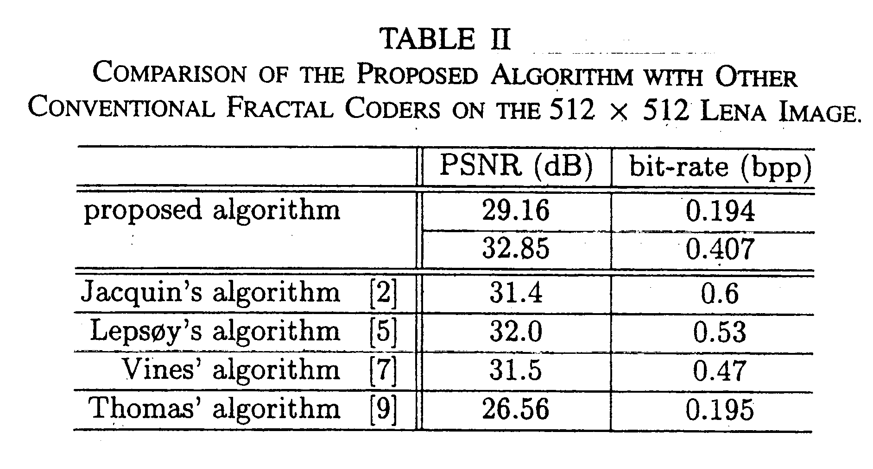
- Conclusion
FVQ is capable of eliminating the redundancy in the codebook without any side information, in addition to exploiting the self-similarity in real image effectively.
Created by: Chia-Hao Yang
Date: December 17, 1998

